**Radeon ProRender plug-in for Unreal Engine 4**

User Guide v1.0

This document is a user and setup guide with tips and tricks on how to render photorealistic images in real-time, set materials and lighting.

**DISCLAIMER**

The information contained herein is for informational purposes only and is subject to change without notice. While every precaution has been taken in the preparation of this document, it may contain technical inaccuracies, omissions, and typographical errors, and AMD is under no obligation to update or otherwise correct this information. Advanced Micro Devices, Inc. makes no representations or warranties with respect to the accuracy or completeness of the contents of this document, and assumes no liability of any kind, including the implied warranties of non- infringement, merchantability or fitness for particular purposes, with respect to the operation or use of AMD hardware, software or other products described herein. No license, including implied or arising by estoppel, to any intellectual property rights is granted by this document. Terms and limitations applicable to the purchase or use of AMD’s products are as set forth in a signed agreement between the parties or in AMD's Standard Terms and Conditions of Sale.

©2018 Advanced Micro Devices, Inc. All rights reserved. AMD, the AMD arrow, FirePro, Radeon Pro, Radeon ProRender and combinations thereof are trademarks of Advanced Micro Devices, Inc. in the United States and/or other jurisdictions. Autodesk, the Autodesk logo, and 3ds Max are registered trademarks or trademarks of Autodesk, Inc., and/or its subsidiaries and/or affiliates in the USA and/or other countries. Windows is a registered trademark of Microsoft Corporation in the United States and/or other jurisdictions. Other names are for informational purposes only and may be trademarks of their respective owners.

Table of Contents

Supported Platforms 5

Software 5

Operating System 5

Install Radeon ProRender plug-in 6

Radeon ProRender for Microsoft Windows 6

Getting Started 7

Setup a simple scene 7

Create a ProRender® material 9

Render the scene 10

Overview of User Interface 12

ProRender Viewport 12

Photolinear tonemap 13

Simple tonemap 14

ProRender Material 16

ProRender Settings 19

RPR Static Mesh Editor 21

OVERVIEW

Radeon™ ProRender is a free un-biased rendering add-in for your design needs in Unreal Engine 4. Using physically accurate path-tracing technology, Radeon ProRender can produce stunning photorealistic images of your scene and provides real-time interactive rendering and continuous effects adjustments to help create the perfect rendered image. The Radeon ProRender plugin is fully integrated into Unreal Engine 4 – it supports the Unreal Engine 4 lights, materials, and textures and renders your geometry accurately.

This user guide will describe how to use and setup Radeon ProRender for Unreal Engine 4.

Supported Platforms

Radeon ProRender for Unreal Engine 4 runs on both GPUs and CPUs. OpenCL™ 1.2 is required for GPUs.

Software

* Unreal Engine 4.18
* Unreal Engine 4.19

Operating System

* Microsoft Windows® 8.1 (64-bit)
* Microsoft Windows® 10 (64-bit)

Install Radeon ProRender plug-in

Radeon ProRender for Microsoft Windows

Download the Radeon ProRender plug-in for ProRender for Microsoft Windows.

TODO

Getting Started

Setup a simple scene

* Create a new Unreal Engine 4 project and open it
* Create a new empty level. Go to **File** and select **New Level…**, then choose **Empty Level**.
* 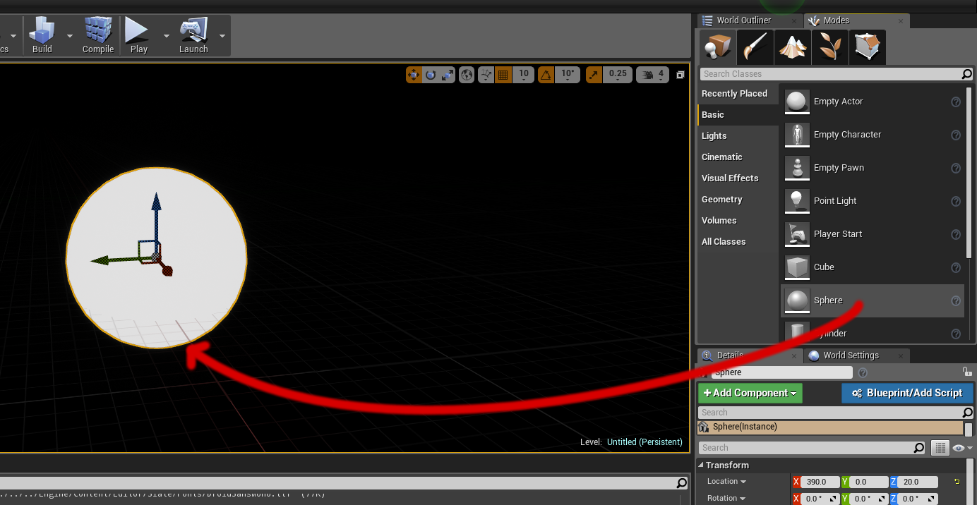From the **Modes** tab, select the **Basic** category and drag and drop a **Sphere** in the viewport.
* From the **Modes** tab, select the **Lights** category and drag and drop a **Sky Light** in the viewport.

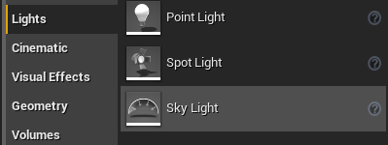

* Select the **Sky Light** in the level, and in the **Details** panel
  + Find **Source Type** and set **SLS Specified Cubemap**
  + On the **Cubemap** property, select **EpicQuadPanorama_CC+EV1**.
  + 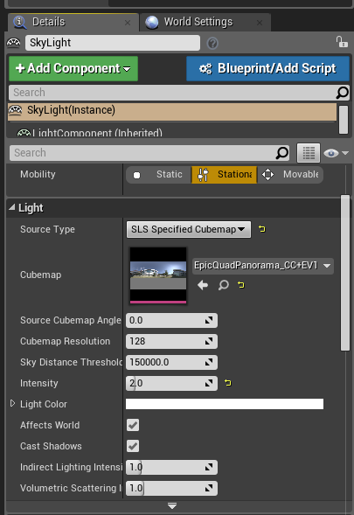Set the **Intensity** to **2.0**

Create a ProRender® material

* Right-click in the **Content Browser** and select **Materials & Textures > ProRender Material**
* 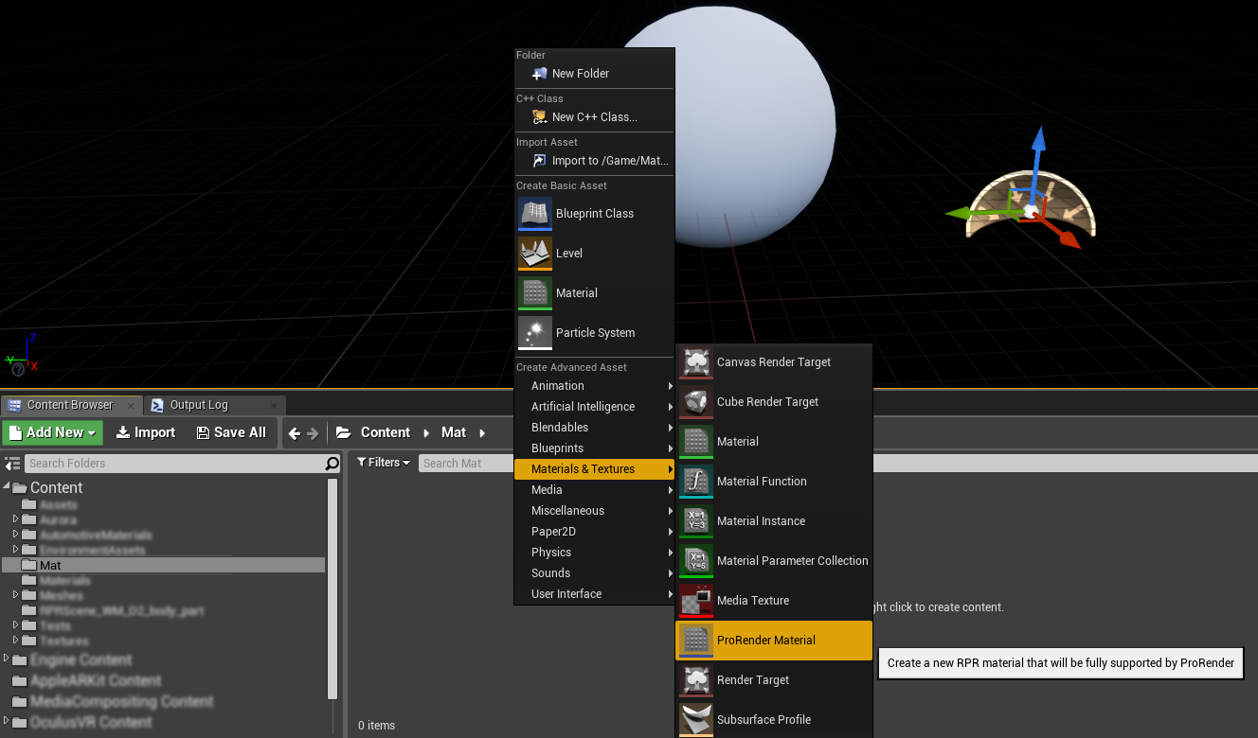If the **ProRender Material** doesn’t appear, make sure that the plugin is correctly installed
* Double-click the **ProRender Material** to edit it
* Click on the color block in the Diffuse Color row and select the color you want
* 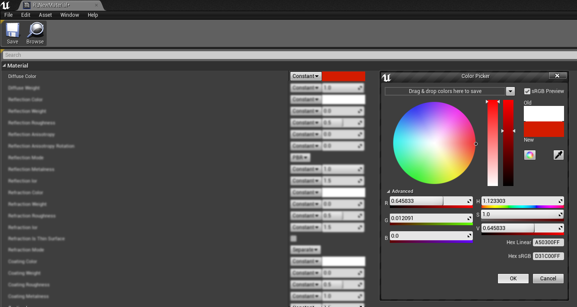Click **Save** and close the material editor
* Drag and drop the ProRender material on the **Sphere** (or on the material slot of the mesh)

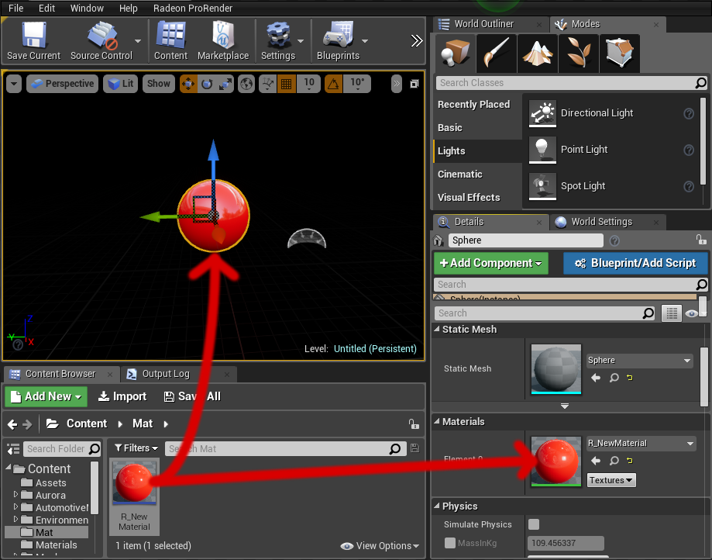

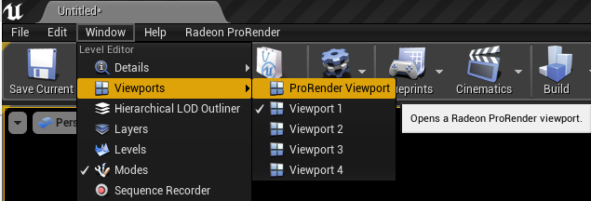Render the scene

* Open the **ProRender Viewport** from **Window > Viewports > ProRender Viewport**
* To start, set the **Quality** to **Interactive** and set the number of **Megapixel** to the minimum
* 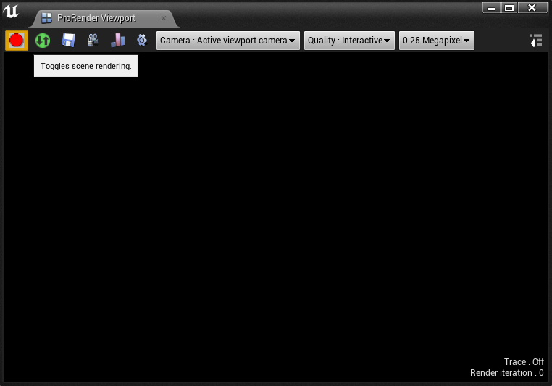Press the red button to toggle the scene rendering
* The result should appear quickly
* 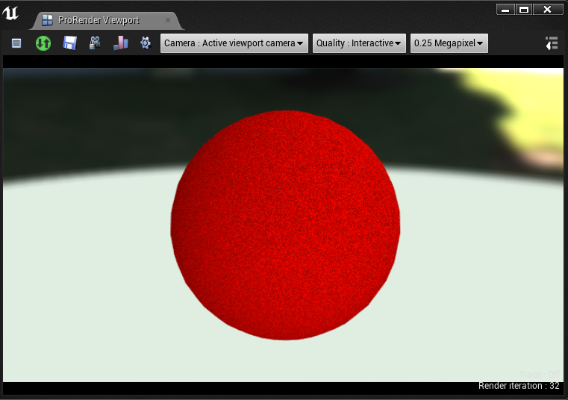Congratulations! You got your first RPR rendering in Unreal Engine 4!

Overview of User Interface

ProRender Viewport

Overview

The ProRender viewport allows you to start the ProRender rendering, setting post process effects and save your rendered picture.

Controls

Most of the controls are explained via tooltips if you hover a button with your mouse. Here is a more detailed explanation of the controls.

 Start/Stop the rendering of the scene.

 Start/Stop the synchronization with the scene. If enabled, making change in the scene or changing the camera view will automatically update the rendering.

 Save the rendered picture.

 Start/stop the ProRender camera orbitting. If enabled, you can drag your mouse directly on the ProRender viewport to move the camera around your object. The scene rendering and the scene synchronization need to be enabled to work.

 Toggles RPR Tracing. If enabled, debug informations will be generated during the rendering. These informations are important to help the development of ProRender. If you need to contact the support for any problem, you should probably join these logs. They can be found in **[YourProject]/Saved/RadeonProRender/Trace**.

 Rebuild the RPR scene. Force to rebuild the scene manually if a change has been made but the synchronization did not manage it automatically, or if the synchronization is disabled.

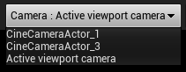 Set the camera you want to use for the RPR rendering. You can add more UE4 camera in your scene and they will become available here.

 Quality of the render. You can select from **Interactive** (lowest quality) to **High** (high quality). The higher the quality, the longer it will take to render.

 Set the number of pixels to render. The higher the number, the longer it will take to render.

Show/hide post effects.

Post Effects

The final render can be altered by multiple settings, mainly based on real camera settings, like exposure or f-stop.

## Photolinear tonemap

* Sensitivity : sensitivity of the camera sensor. It is the equivalent of the **ISO**. Affect brightness.

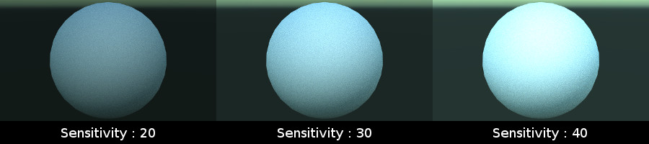

* Exposure : defines the exposure of the camera. Affects brightness.

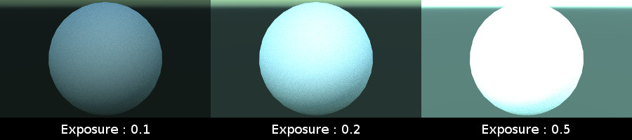

* F-Stop : defines the opening of the camera aperture. Affects brightness and depth of field.

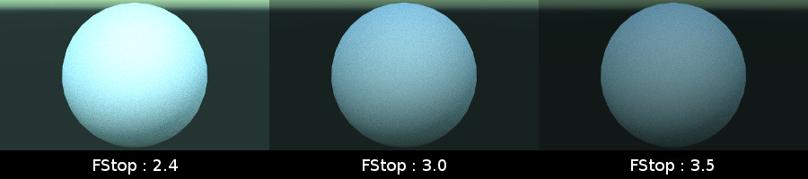

## Simple tonemap

* Exposure : defines the brightness of the final render. Thus, **0.0** will not affect the render at all (that is not the case of the **Photolinear tonemap exposure**).

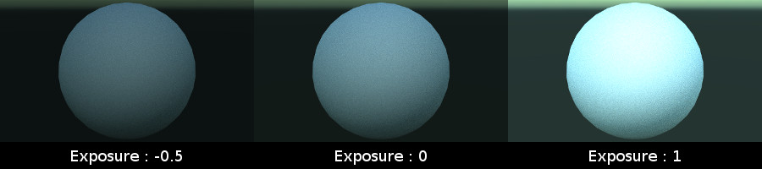

* Contrast : defines the contrast of the final render.

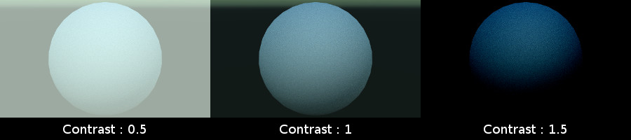

* White balance : defines the white balance from the color temperature (expressed in Kelvin).

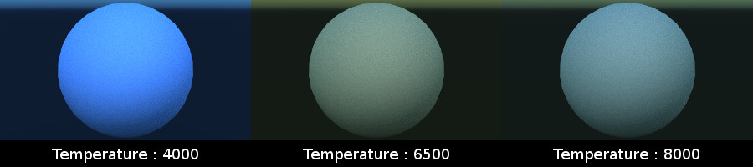

* Gamma correction

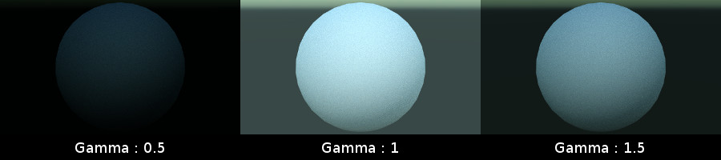

Navigation

Since the active camera is used for the ProRender rendering, you can navigate using Unreal Engine 4 controls in the Unreal Engine 4 viewport.

You can also click on to enable camera orbitting. Once it is active, you can left-click and drag your mouse on the ProRender Viewport to make the camera orbit around your object.

*The scene synchronization must be activated to make the camera orbitting mode works.*

Click again on the icon to left the orbitting mode.

ProRender Material

Overview

ProRender materials are special materials that can be set an on mesh in Unreal Engine 4 like any other material. However, it cannot be customized via the standard Material Graph editor.

Only a set of predefined parameters can be set to customize the material.

Creation of a new ProRender material

You can create a new ProRender material from scratch using **Add New** or doing right-click in your **Content Browser** (in the directory content panel).



Import ProRender uber-material

You can importer ProRender material using the **Import** button and selecting your ProRender material.

*Only ProRender uber-materials are supported! If you are not sure that your ProRender material is a uber-material, open it with a text editor and search for a node whose the type is* ***Uber****.*

*Here is an example of what a ProRender uber-material looks like :*

<?xml version="1.0" encoding="UTF-8"?>

<material name="Master_material_textured">

<node name="UberMaterial #0" type="UBER">

<param name="diffuse.color" type="float4" value="1, 0, 0, 1" />

<param name="diffuse.weight" type="float4" value="1, 1, 1, 1" />

...

</node>

</material>

In the ProRender settings (in the Project Settings), you can set the path for imported textures. By default, textures will be in **/Game/Textures** (**/Game** represents your content root directory in UE4).

Parameters

The parameters can be split in multiple categories and for each categories, there is a Weight properties. This weight allow you to activate/deactivate each category.

* Diffuse Color
* Diffuse Weight
* Reflection Color
* Reflection Weight
* Reflection Roughness
* Reflection Anisotropy
* Reflection Anisotropy Rotation
* Reflection Mode
* Reflection Metalness
* Reflection Ior
* Refraction Color
* Refraction Weight
* Refraction Roughness
* Refraction Ior
* Refraction Is Thin Surface
* Refraction Mode
* Coating Color
* Coating Weight
* Coating Roughness
* Coating Metalness
* Coating Ior
* Coating Mode
* Emission Color
* Emission Weight
* Emission Mode
* Transparency
* Normal
* Bump
* Displacement
* SSS Absorption Color
* SSS Scatter Color
* SSS Absorption Distance
* SSS Scatter Distance
* SSS Scatter Direction
* SSS Weight
* SSS Sub Surface Color
* SSS Is Multi Scatter
* Use Tri Planar
* Scale
* Angle

ProRender Settings

You can access the ProRender settings from the **Radeon ProRender** menu in the main bar, or you can access them from the **Project Settings** and find **Radeon ProRender**, in the **Plugins** category.

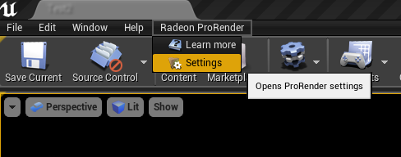

* General
  + Render Cache Path : defines the save path for the cache of ProRender.
  + Trace Folder : defines the folder where your traces will be saved. These traces are essential for debugging.
  + 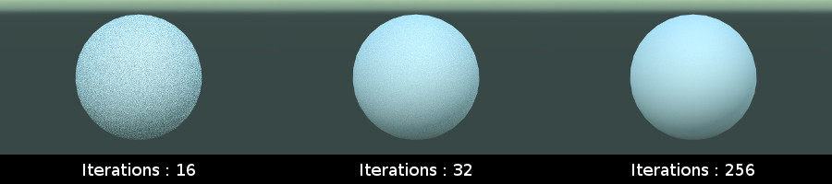Maximum Render Iterations : defines the number of iterations. The higher the number of iteration, the higher the quality and the time to render. If your image suffers from noise, you may want to start from here.
* Devices
  + Enable GPU*x*: enable the use of a GPU for the rendering. If checked and the GPU is compatible, it will be used.
  + Enable CPU : enable the use of the CPU for the rendering.
* Materials
  + Uber Material : defines the uber material template in UE4. This is the base material for all ProRender materials. Be careful when modifying this property.
  + Default Root Directory for Imported Textures : defines the directory path where the textures should go when you import a ProRender material.
* Image Manager
  + Use Error Texture : defines if the Error Texture should be used. If checked, the error texture will be used if the texture cannot be used in ProRender. For now, only textures compressed in RGBA with NoMipmaps are supported.
  + Error Texture : defines the texture to use if the material textures cannot be used.

RPR Static Mesh Editor

Radeon ProRender plug-in for Unreal Engine 4

User Guide v1,0

Written by: Arnaud Begue

04/07/2018

©2018 Advanced Micro Devices, Inc.

All rights reserved.